|  |  |
| --- | --- |
| * The Guiding Light   Volume 3 Issue 6 <https://www.knoxschools.org/fairgarden> Published Monthly **February 2022**  **Important Dates:**  2/10- Spring Pictures (Pre-Pay Only)  2/11- King and Queen Money due to the front office by the end of the day (1:15 pm)  2/25- Black History Program and King & Queen Celebration (In-Person at 9:00 am in Fair Garden’s Gym)  2/21- Inservice Day **(No School)**  2/28-3/4- Read Across America Week  3/3- UT CRRAFT Parent Night (6:00-7:00 pm)  3/11- End of 3rd 9 Weeks  3/14- 3/18- Spring Break **(No School)**  3/21-Parent Engagement Opportunity (Parents As Teachers- Time Management 6:00-7:00 pm)  3/21- Fair Garden Re-Enrollment Packets Will Be Sent Home  3/25- Students’ 3rd Nine Weeks  Performance Reports Are Sent Home  4/13- PK4 Cap & Gown and Group Pictures  4/14- Fair Garden PK Round-Up  **New Registrations Only For Fair Garden**  In March, Fair Garden Preschool will begin taking applications for the 2022-2023 school year. Students must be 3 years old by August 15 and 4 years old by August 15. You must live in a Title 1 school zone. Current 3-year-old students should receive reenrollment forms from Fair Garden on **March 21**. Thank you.  Logo  Description automatically generated with medium confidence | Screen%20Shot%202018-08-31%20at%2010.17.55%20AM.pngScreen%20Shot%202018-08-31%20at%2010.17.55%20AM.png  **Please make sure to check our school-wide Dojo, your child’s class Dojo, and our school website to stay informed about events that are happening at Fair Garden.** Please join our electronic platform: **Fair Garden’s Twitter:** <https://twitter.com/fair_garden> **Thank you. ☺**  **A Note From Our Social Worker Deanna Gnage**  **Safety Steps When the Touching Rule is Broken**  This week we learned the “Touching Rule”:  A bigger person should not touch your private body parts except to keep you clean and healthy.  Next, we will begin learning the “Safety Steps” that will guide them to know what to do if someone breaks the Touching Rule.   1. **Say words that mean “No.”** 2. **Get away.** 3. **Tell a grown up.**   **Safety Steps**  We encourage you to help your child think of different ways of saying “No.” (For example: “Leave me alone.” “Stop that.” “I’m not allowed to play touching games.” “I don’t like that.”)  Help your child understand that getting away can be as simple as moving away from someone or going to another room.  Or it might mean running home immediately.  Help your child identify whom to tell and have him or her practice telling.  Sometimes a child may not be able to get away; then the telling becomes even more important.  Help your child practice responding to the following:   * What would you do if a grown-up you know wants to touch your private body parts—and it’s not to keep you clean and healthy? * What words would you say that mean “No”? * How would you get away? * Name a grown-up you could tell. * Whom else could you tell?   Children need to be able to identify adults to talk to, both inside and outside the family, since you may not always be available.  Children also learn in this lesson that it is never a child’s fault if someone breaks the Touching Rule.  Encourage your children to come to you if she/he has any questions about using the Touching Rule or the Safety Steps.  **Mrs. Gnage, School Social Worker/Counselor**  (865) 257-5826  deanna.gnage@knoxschools.org    A group of kids holding a sign  Description automatically generated with low confidenceA group of kids holding a sign  Description automatically generated with low confidenceA group of kids holding a sign  Description automatically generated with low confidenceA group of kids holding a sign  Description automatically generated with low confidenceA group of kids holding a sign  Description automatically generated with low confidenceA group of kids holding a sign  Description automatically generated with low confidence |
| Positive Quote:     | large_651e2a4a-23cf-4813-b6fe-96cd6a51692e.jpg**A Message from Mrs. Spikes** large_651e2a4a-23cf-4813-b6fe-96cd6a51692e.jpg  Thank you, parents, for being our valued partners in this educational journey at Fair Garden. Wow, our students are getting so SMART every day. At Fair Garden, students are recognizing rhyming words, decoding, blending sounds together to read words, writing their names, adding numbers together to get an answer, measuring, and really working hard every day to be kindergarten ready. Remember, we need every student at school EVERY day he or she doesn’t have a fever, isn’t vomiting, having diarrhea, or hasn’t been told to quarantine/isolate. Missing school causes children to miss valuable instruction that is preparation for kindergarten.  Thank you all for valuing education at Fair Garden. Parents, I appreciate your daily support of our school. Thank you for letting your light shine for good and lighting a path for GREATNESS. You are important to our school’s success.  Thank you,  Principal Spikes  A picture containing clipart  Description automatically generatedA picture containing text, vector graphics, clipart  Description automatically generatedA picture containing clipart  Description automatically generatedA picture containing text, vector graphics, clipart  Description automatically generatedA picture containing clipart  Description automatically generatedA picture containing text, vector graphics, clipart  Description automatically generated  Warm regards,  Principal Spikes  A picture containing clipart  Description automatically generated  large_651e2a4a-23cf-4813-b6fe-96cd6a51692e.jpglarge_651e2a4a-23cf-4813-b6fe-96cd6a51692e.jpglarge_651e2a4a-23cf-4813-b6fe-96cd6a51692e.jpg |

Fair Garden will be having PK Round-Up for new students that are wanting to attend our school for the 2022-2023 school year on **Thursday, April 14 at 4:00-6:00 pm at Fair Garden.**

Nurse’s Notes

**Clinic Reminders:**

* If your child will be absent for isolation or quarantine, please notify Nurse Amanda.

865-594-1320 Option 1 Class Dojo amanda.scheele@knoxschools.org

* + For information regarding isolation/quarantine visit: [Cases and Contacts (tn.gov)](https://www.tn.gov/content/tn/health/cedep/ncov/cases-and-contacts.html) <https://www.tn.gov/content/tn/health/cedep/ncov/cases-and-contacts.html>

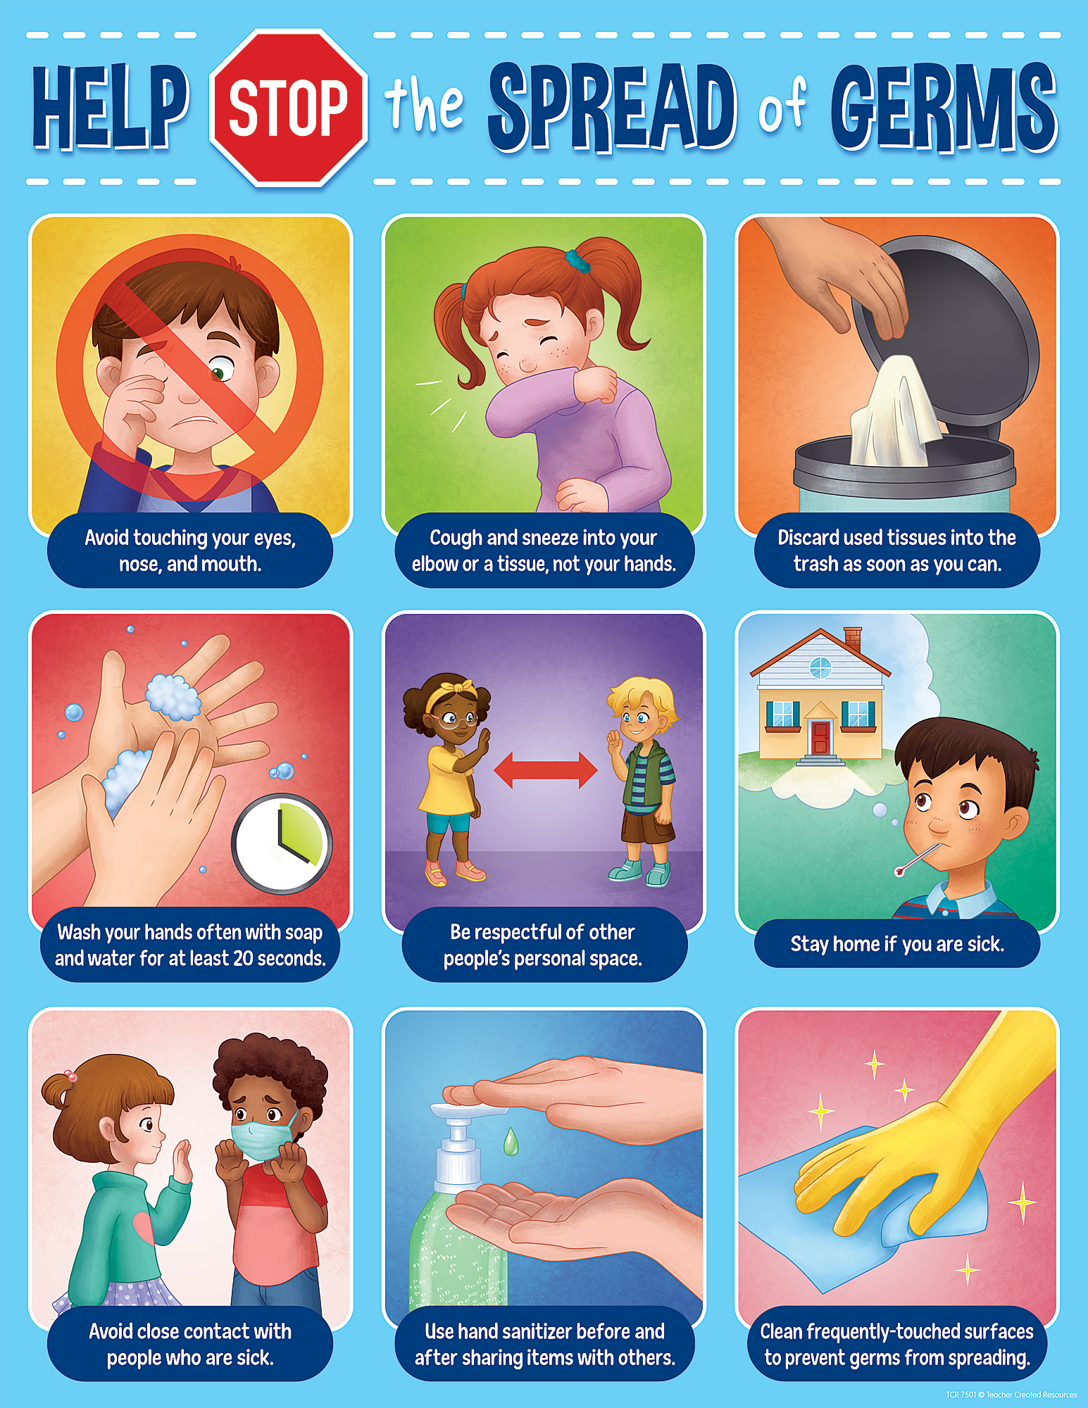

**From the Fair Garden PTA:**

“Thank you to everyone who brought food for the January Staff Appreciation Breakfast! We are so glad we get to love on our staff the way we do, and we are excited to do it again later this month. Remember, this is a potluck-style breakfast on the last Friday of each month. PTA officers will send out this month’s sign-up sheet in a week or so, so be on the lookout!

Also, our next PTA meeting is Saturday, 2/12 from 2-3pm virtually. The link will be emailed out, and of course, if you aren’t on the PTA email list but want to be, please reach out to us at fairgardenpta@gmail.com.

We can’t wait for all the things coming up this year - from yearbooks to a Spring Carnival and more! And it’s all thanks to our amazing community that wants to be involved and supportive — we are grateful for you!

Sincerely,

Thank you,

-Fair Garden PTA Officers, Allison Comer, PJ Hoskins, and Taurika Boateng

